TASK-1
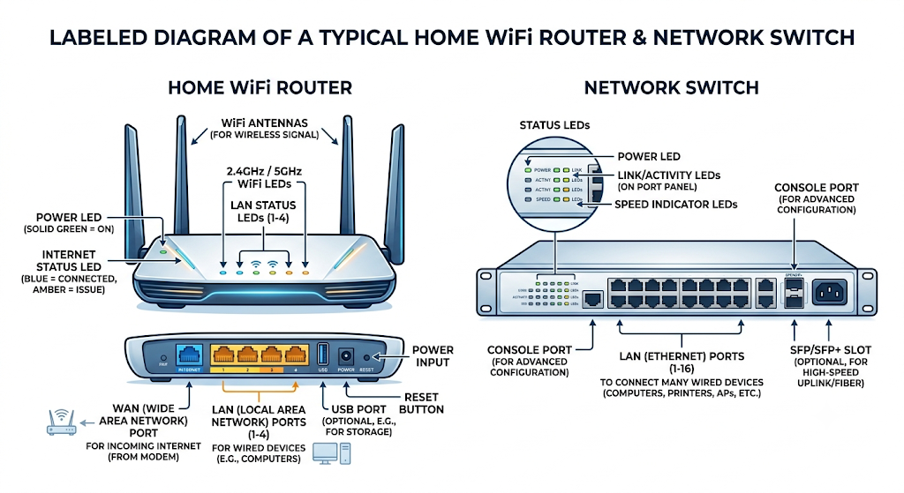

TASK-2
- What they connect: A router connects your network to the internet. A switch connects multiple devices together within the same room or building.
- What addresses they read: A router uses IP addresses to send data across the web. A switch uses MAC addresses (physical hardware addresses) to send data to a specific plugged-in device.
- Where they send traffic: A router directs traffic outside to the world. A switch keeps traffic local, sending it only to the specific computer or printer that needs it.
TASK-3
1. Home Router
- Power Port: On the back; plugs into the wall to supply power.
- Ethernet Ports: On the back; 1 WAN port (colored) connects to the internet modem, and 4 LAN ports connect to your wired devices.
- LED Indicators: On the front/top; lights turn on or blink to show power, internet connectivity, and Wi-Fi activity.
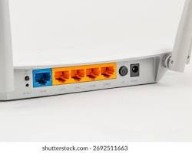
2. Network Switch
- Power Port: On the back; plugs into the wall for power.
- Ethernet Ports: On the front; a long row of identical ports used to wire many devices (like PCs and printers) together.
- LED Indicators: Right on/above each port; blinks to show that a specific connected device is transferring data.
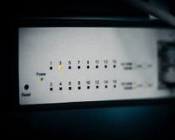
TASK-4
Scenario: Gaming Café Setup
1. First Device Connected: The Router
- Action: Connect the ISP internet line directly into the Router (via its WAN port).
- Why: The router acts as the gateway to the internet. It takes your single public connection from the ISP, protects your network with a firewall, and assigns local IP addresses to all your equipment. A switch cannot manage an internet connection on its own.
2. How to Connect the 8 Gaming PCs
- Action:
  - Plug an Ethernet cable from one of the router's LAN ports into an 8-port (or 16-port) Network Switch.
  - Plug all 8 Gaming PCs directly into the switch using Ethernet (Cat6) cables.
Why This Setup Works Best
- More Ports: Routers usually only have 4 LAN ports. A switch instantly expands your network so all 8 PCs can plug in.
- Zero Lag: Hardwiring every PC through the switch guarantees maximum speed and ultra-low latency for seamless multiplayer gaming and smooth HD/4K IPL streaming without Wi-Fi dropouts.

